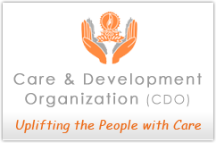
Winter clothes program

Brick factories have become extremely prevalent in Nepal. Its employ a transient workforce of between 400-500 worker and 40 to 50 children.
Extreme poverty has left them without access to either education or health care. The hazardous work, long hours, low pay and unsanitary living conditions combine to pose very serious health threats to the workers. Their low income hardly allows them to have warm clothes for the winter. Most of workers have single blanket for their whole family in winter. They make bed out of unbaked bricks and used single mat made out of rice straw. Due to cold most of the new born baby suffer from pneumonia and some even died and the pregnant women suffer from body swelling.

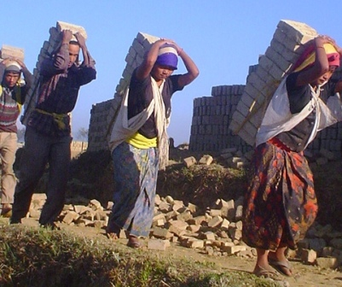
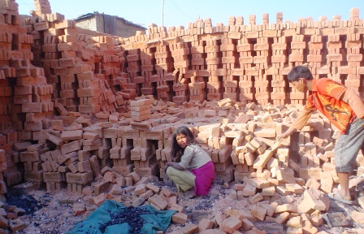
Care and Development organization (CDO) has created a number of programs based on providing mobile clinic, both informal and formal education and Children Development Program to brick factories workers and their children.

Every winter CDO distributed winter clothes, shoes and slippers to children and workers of 6 brick factories. And they were contribution by the CDO friends. In 2010 we distribute -
150 children wear.
50 man got pant and trousers.
75 man got sweaters and jackets
60 women wear.
45 women got shawl.
20 got shoes and sandals.
10 family got blankets.

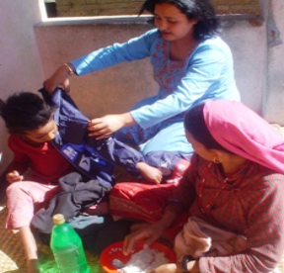
Words of Maili Nepali………
“By getting the jackets my daughters were very happy and it is their first time wearing such new jacket. We would like to thanks CDO for providing warm clothes and food to my daughter and Son”.

Our Work

For more Information Please Contact Us:

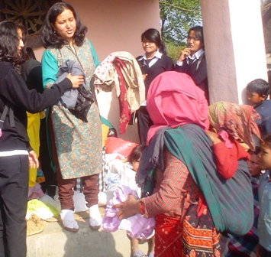
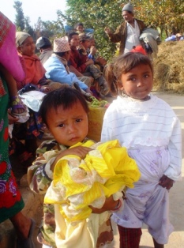

PO Box 11978
Kathmandu, Nepal

Phone:
(977)-15560403

Website:
caredevelopment.org

E-Mail:
cdo@caredevelopment.org

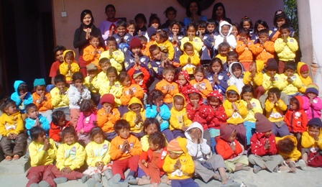
Care and Development Organization would like to thank all CDO friends for all the support and hope to have in future.
Your Donation will help to change the lives of thousands of children and their families in Nepal simply by volunteering your time, hosting a fundraiser, or donating to our organization.

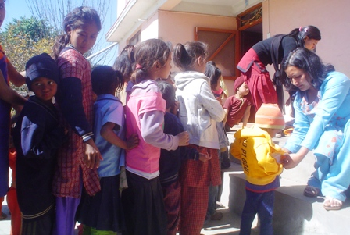

Please donate -
Account Name: - Care and Development Organization
Account No: - 0201017500655
Swift Code: - NARBNPKA
Bank: - Nabil Bank
Address: - New Road, Kathmandu Nepal

